**Administrative Setup Documentation**

**For**

**Wearable RFID Interaction Tracking System**

**Team Members:** Mit Dalsania, Ken Hodel, Myles Adams, Anthony J. Popolo

**Instructor:** Professor Filippos I Vokolos

**Cycle:** III

**Date Submitted: 6/1/2015**

Table of Contents

Prerequisites 3

Software 3

Materials 3

Installing Required Software 7

Installing XAMPP: 7

Configuring XAMPP MYSQL Password: 7

Creating the RFID database and importing its structure: 7

Copying Over Web Files: 8

Installing Adobe Flash: 8

Installing Location HTTP Forwarder: 8

Installing Synapse Portal Software: 9

Hardware Setup 10

RF300 & Protoboard Setup 10

Inserting RF300 into Protoboard: 10

RF300 Pin Layout: 13

Finding RF300 MAC Address: 14

Prepping New RF300 Chips: 15

Restarting RF300 Chips while on Protoboard: 17

Flashing Hardware 20

Synapse Portal Software Installed 20

Flashing the PC Reader: 20

Updating Reader Node code after Flashing PC Reader: 24

Flashing the Reader Nodes: 24

Flashing the Location Tags: 25

Erasing/Reflashing an RF300 Chip: 25

Hardware Assembly 28

This section goes over the physical assembly of the different RF300 chips once they have been flashed and their different power sources. 28

Soldering Reader Node Power Cable: 28

Soldering Location Tag Power Cell: 31

Attaching an Antenna to the RF300 Chip: 36

# Prerequisites

## Software

Microsoft Windows 7, 8, and 8.1

User Account with Administrative Privileges

XAMPP

Latest Adobe Flash

Location HTTP Forwarder

Synapse Portal Software

DSL+ Internet connection

## Materials

**Note: This setup guide assumes that you have the exact hardware depicted below. Other hardware may be incompatible with these setup instructions.**

**Tool with metal tip and non-conductive handle (such as a screwdriver)**

**Synapse SN171 Proto Board “Protoboard”**

|  |
| --- |
|  |
| **Figure 1. Synapse SN171 Proto Board** |

**RS232 to USB Convertor “USB Adapter”**

|  |
| --- |
|  |
| **Figure 2. RS232 to USB Convertor** |

**Synapse RF300 Module “RF300”**

|  |
| --- |
|  |
| **Figure 3. Synapse RF300 Module Front & Rear View** |

**DC Terminals 2.1x5.5mm “DC Adapters”**

|  |
| --- |
|  |
| **Figure 4. Female Power Adapters** |

[**http://ecx.images-amazon.com/images/I/617pFOroGrL._SL1100_.jpg**](http://ecx.images-amazon.com/images/I/617pFOroGrL._SL1100_.jpg)

**Neewer Power Adapter DC 3V 1A**

|  |
| --- |
|  |
| **Figure 5. Power Adapter DC 3V 1A** |

[**http://ecx.images-amazon.com/images/I/51hkFw7GBLL._SL1001_.jpg**](http://ecx.images-amazon.com/images/I/51hkFw7GBLL._SL1001_.jpg)

**Schmartboard Male to Female Jumpers**

|  |
| --- |
|  |
| **Figure 6. Male to Female Jumper** |

[**Renata VBH2032-1**](http://www.mouser.com/ProductDetail/Renata/VBH2032-1/?qs=vREuJMRZ4N%252b2sOQnSrbKRg%3D%3D) **Battery Cell Holder**

|  |
| --- |
|  |
| **Figure 7. Battery Cell Holder** |

[**http://www.mouser.com/ProductDetail/Renata/VBH2032-1/?qs=vREuJMRZ4N%252b2sOQnSrbKRg%3D%3D**](http://www.mouser.com/ProductDetail/Renata/VBH2032-1/?qs=vREuJMRZ4N%252b2sOQnSrbKRg%3D%3D)

**CR2032 Batteries**

|  |
| --- |
|  |
| **Figure 8. CR2032 Battery** |

[**http://www.hyjo.co.uk/ekmps/shops/hyjoltd/images/cr2032-lithium-battery-3v-23115-p.jpg**](http://www.hyjo.co.uk/ekmps/shops/hyjoltd/images/cr2032-lithium-battery-3v-23115-p.jpg)

# Installing Required Software

All of the following software must be installed for the system to function.

# Installing XAMPP:

XAMPP must be installed in order for the web interface for viewing data to function and for the database which stores all data to function. For instructions on how to install XAMPP, please refer to the following site:

<http://www.wikihow.com/Install-XAMPP-for-Windows>

## Configuring XAMPP MYSQL Password:

A XAMPP MYSQL password must be created once XAMPP is installed in order for the system to run. For instructions on how to create a password, refer to the following site:

<http://veerasundar.com/blog/2009/01/how-to-change-the-root-password-for-mysql-in-xampp/>

# Creating the RFID database and importing its structure:

Once the password for XAMPP MYSQL has been set the database structure needs to be imported

1. Navigate to localhost/phpmyadmin/ and log in with the credentials that were set in the previous step
2. In the left-hand navigation column, click “New” at the top of the list to create a new database. Name the database “rfid2” (without quotes) and click “Create”
3. Click on the new database created in the left-hand navigation column
4. Click on the Import tab at the top of the main window
5. Click “Browse” and navigate to the location of the supplied media and select the rfid.sql file in the Web folder. Click go to import the database structure into the newly created database
6. Log out of phpmyadmin

**Note: Once a password is created you must update a few configuration files with these passwords.**

1. In the “Web” directory from the supplied media, there will be a “locationtrack” folder Open that folder and then navigate to the “Includes” folder and open the config.php file within with Notepad
2. The “db_password” variable needs to be updated to reflect the changes made above
3. Once the variable is updated, hit “Save” and close the file
4. Navigate back up to the “Web” directory and enter the “interface” folder
5. Open the credentials.php file and change the $username and $password variables to the username and password used to setup XAMPP MYSQL in the previous section. (Note if you named the database created in the previous step something other than rfid2 the $db variable will need to be changed in this file as well.)
6. Make sure the username and password values are contained within single quotes, save, and close the file

### Copying Over Web Files:

1. Copy all files and folders in the “Web” directory from the supplied media and paste them into the following directory (without the quotation marks) “C:\xampp\htdocs\”

# Installing Adobe Flash:

For instructions on how to install Adobe Flash or to check if it is installed on your browser, refer to the following site:

<https://helpx.adobe.com/flash-player.html>

# Installing Location HTTP Forwarder:

1. Open the HTTP Forwarder folder from within the supplied media
2. Run the “setup.exe” and hit “Install” or “Allow” on any popup that may come up
3. The HTTP Forwarder is now installed and can be accessed from within the Start Menu.
4. You can find it in the Start Menu folder called “Location Tracking”
5. Start the Location Tracking client and enter the following into the server field without the quotation marks “<http://localhost/locationtrack/?p=clientapi&password=track111>”
6. Close the Location Tracking Collection Client window to save the server field
7. The Location HTTP Forwarder is now installed and configured

# Installing Synapse Portal Software:

1. Create an account login at <http://forums.synapse-wireless.com>
2. Visit <http://forums.synapse-wireless.com/showthread.php?t=9>
3. Download the latest version of the Portal IDE for Windows
   1. Make sure no Synapse devices are connected to the computer at this point
4. Unzip the downloaded file and run the Portal Setup executable within
5. Follow the onscreen instructions and install all portions of the program if asked
6. Once setup is finished, copy all files in the “Python Images” directory from the supplied media and paste them into the following directory (without the quotation marks) “C:\Users\%username%\Documents\Portal\snappyImages”
7. The Synapse Portal software is now installed and the python firmware is in place

# 

# 

# Hardware Setup

This portion contains sections that contain information about how to setup the hardware. The recommended order to follow these sections for new chips is as follows:

1. RF300 & Protoboard Setup
   1. Prepping New RF300 Chips
2. Flashing Hardware
   1. Flashing the PC Reader
   2. Updating Reader Node code after Flashing PC Reader
   3. Flashing the Reader Nodes
   4. Flashing the Location Tags

**NOTE:** The other sections not mentioned may be referenced in the sections above.

# RF300 & Protoboard Setup

## Inserting RF300 into Protoboard:

1. Connect the RF300 chip to the Protoboard by lining up the corresponding labeled pins on the two devices.
   1. Female ends on Protoboard (Red boxes show locations and labels of pins 1 and 24):

|  |
| --- |
|  |
| **Figure 9. Protoboard Female End Locations** |

* 1. Male ends on RF300 (Red boxes show locations and labels of pins 1 and 24):

|  |
| --- |
|  |
| **Figure 10. RF300 Male End Locations** |

* 1. Line up the highlighted pins in the images above (Pin 1 end on the Protoboard to Pin 1 on the RF300 chip etc.) and push in.
  2. The end result should look like this:

|  |
| --- |
|  |
| **Figure 11. Attached RF300 to Protoboard** |

### RF300 Pin Layout:

As seen in the image below, there are 24 pins on the RF300 chip. Pin 1 is on the top right of the image and pin 12 is on the bottom right of the image. Then pin 13 starts on the bottom left and pin 24 is on the top left.

|  |
| --- |
| Pin Layout.png |
| **Figure 12. RF300 Pin Layout** |

### Finding RF300 MAC Address:

Highlighted in red below is where to find the MAC Address on the Synapse RF300 chips. **However, you must ignore the first two digits and only take the six following characters, therefore as seen in the example in Figure 13, the MAC Address of the RF300 chip is 5E585E, not 165E585E.** All MAC Addresses will be six characters long.

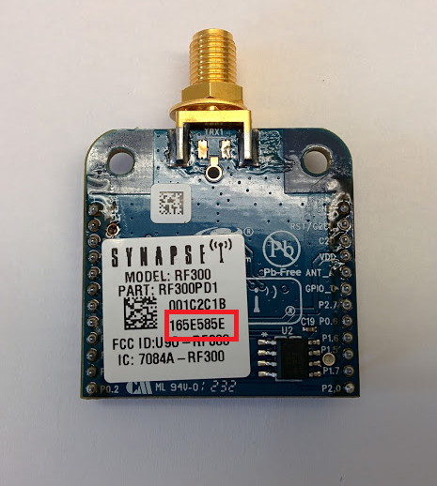

**Figure 13. Mac Address Location on RF300 Chip**

# Prepping New RF300 Chips:

When new RF300 chips are purchased, they are encrypted and, in order to work in this system, this encryption must be removed. This is done by flashing an unencrypted firmware onto the chips.

1. Connect the RF300 chip to the Protoboard. Instructions in “Inserting RF300 into Protoboard” section.
2. Connect the Protoboard to its power cable and connect the power cable to an outlet.
3. Using the USB adapter, hook up the Protoboard to the computer running the Portal software.
4. Open Portal and you should see a “Connect to Port” window:

|  |
| --- |
|  |
| **Figure 14. Port Connection Window** |

1. When the window comes up, hit “Cancel”
2. Click on the “Options” dropdown in the top left corner of the window and then hit the “Firmware Upgrade...” button

|  |
| --- |
|  |
| **Figure 15. Firmware Upgrade Under Options** |

1. That will make the following window appear:

|  |
| --- |
|  |
| **Figure 16. Flash Upgrader** |

8. Hit the  button on the right side which should fill in the port dropdown with the correct COM port.

1. If it does not automatically fill up, hit the drop down arrow and there should only be one listed COM port, choose that COM port.

9. Once the COM port is selected, click on the “Open..” button. This will open up a window which will allow you to choose which firmware you want to flash to the connected device.

10. We want to choose “RF300_900FH_SnapV2.4.31.sfi” and hit open.

1. Be careful with this step as there are many similarly named files.

11. Once the Port and the Firmware Image are chosen, hit the Upgrade Button.

12. Here it will ask you to restart the device by shorting pins 23 and 24. Refer to the “Restarting RF300 Chips while on Protoboard” section to see how to accomplish this.

13. Once the pins are shorted the firmware upgrade will start.

1. If any errors come up during the flash, hit OK on the error and hit “Upgrade” again. You may need to repeat this process several times.

14. Once the upgrade process finishes without errors, the firmware is now in a usable and prepped state ready for flashing.

## Restarting RF300 Chips while on Protoboard:

In order to restart the RF300 chips on the Protoboard you must short pins 23 and 24 on the RF300 chip (the two pins must be connected for a short period, the easiest method to accomplish this is to take a metal object such as a screwdriver and use the end to touch both pins at the same time). **Note: It is highly recommended you use something with a plastic handle (or another non-conductive material) to short the pins, you do not want to be in direct contact with the metal that is connecting the two pins together!**

1. In this image, the two pins that need to be shorted are highlighted in the red box:

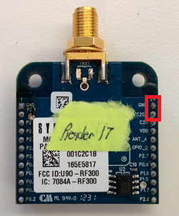

**Figure 17. RF300 Pins to Short**

b. Here is an image depicting the pins being shorted:

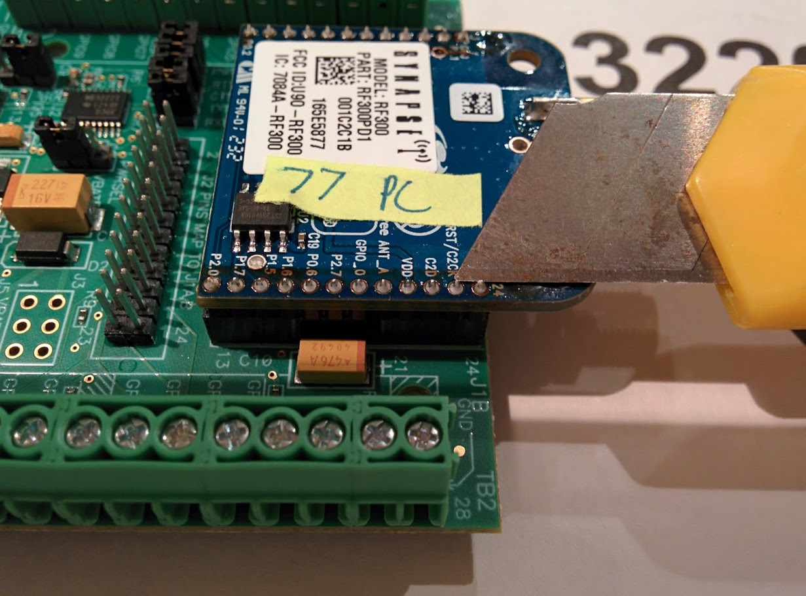

**Figure 18. Shorting RF300 Pins**

**NOTE: It may take a few tries to properly short the pins, if it does not work the first time, try a few more times. The best way to do it is to quickly make contact with both pins with your shorting tool and to pull away. Keeping the tool on the pins for too long will lead to errors.**

# 

# Flashing Hardware

Flashing **Prerequisites:**

Prepped RF300 Chip

## Synapse Portal Software Installed

## 

## Flashing the PC Reader:

**Note:** You will only need one PC Reader. The PC Reader is the RF300 chip that will act as a communications hub for all of the other RF300 chips and forward all of that information to the computer.

1. Connect the prepped RF300 chip to be flashed to the Protoboard. For instructions refer to “Inserting RF300 into Protoboard” section.
2. Connect the Protoboard to its power cable and connect the power cable to an outlet.
3. Using the USB adapter, hook up the Protoboard to the computer running the Portal software.
4. Open Portal and you should see a “Connect to Port” window:

|  |
| --- |
|  |
| **Figure 19. Port Connection Window** |

1. If the window does not appear, click on the “Options” dropdown in the top left corner of the window and then hit the “Connection…” button. That will make the window appear.

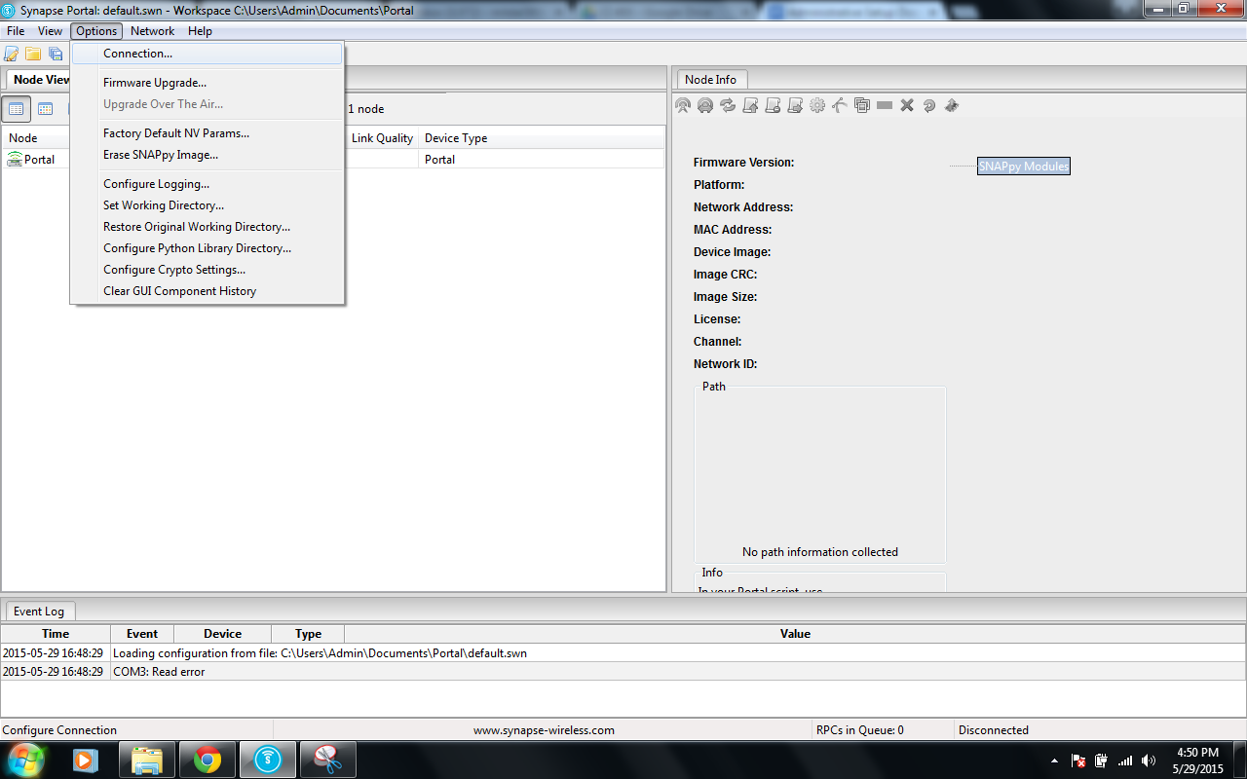

**Figure 20. Connection Menu under Options**

1. In the “Connect to Port” window there should be a drop down labelled “Port.” Choose the available COM port with the device attached.
2. When the correct COM port is chosen, the “Progress” dialogue under the “Port” dropdown will show a similar message to, “Found SNAP Bridge Device on Port COM”

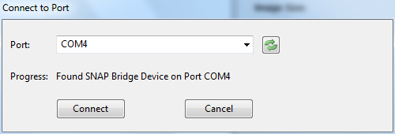

**Figure 21. COM4 Port Chosen**

1. Once the correct COM port is chosen hit the “Connect” button and the connected RF300 chip will appear in the “Node Views” window as seen below:

|  |
| --- |
|  |
| **Figure 22. Node View Window** |

1. Choose the connected RF300 chip and take note of its “Network Address.” This is the chip’s MAC Address. You will need this later for flashing reader nodes.
2. Once the RF300 chip is chosen on the list, click on the following button, , shown in the red highlighted position here:

|  |
| --- |
|  |
| **Figure 23. Upload Snappy Image** |

1. This is the “Upload Snappy Image” button that will allow you to choose an image to flash to the device.
2. Once the button is clicked it will bring up a window with a list of all of the available code to run on the device. Scroll down to “pcreader.py,” highlight it, and click OK.
3. This will flash the selected image onto the tag.
4. To disconnect the Protoboard and RF300 chip from the computer, repeat step 4A and instead of showing you the “Connect” to port window, it will show the following:

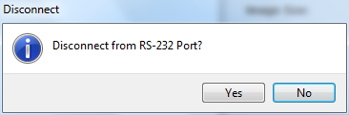

**Figure 24. Disconnect Window**

1. Hit “Yes” and you are free to disconnect the Protoboard from the computer and remove the RF300 chip from the Protoboard.

### Updating Reader Node code after Flashing PC Reader:

Now that you have flashed the PC Reader, you must update the Reader Node python code to include the MAC Address of the PC Reader. This is done in order to make the Reader Nodes connect to the PC Reader to send all of the data they receive.

**NOTE: If you flash a new PC Reader, you must do this step again and reflash all Reader Nodes!**

1. Navigate to C:\Users\%username%\Documents\Portal\snappyImages
2. Right click on readernode.py and choose open with.
3. Choose Notepad.
4. There will be a variable named “PC_LINKED_READER” which will have a value of something like ‘\x**\x**\x**’
5. The MAC Address of the reader node, which you took note of in step 7 of Flashing the PC Reader, will be in the format of **.**.**
6. You will then take that MAC Address and put it in that variable. For example, if the MAC Address I have is 5E.58.77, the variable in the readernode.py file will look like this (without the double quotations) “PC_LINKED_READER = '\x5E\x58\x77'”
7. Hit “File” and then “Save” and close the window.

## Flashing the Reader Nodes:

**Note:** The amount of Reader Nodes you want will depend on the amount granularity of the tracking information you want. The Reader Nodes act as reference points for Location Tags, basically when a Location Tag is closest to a certain Reader Node, it will tell the system that it is at that Reader Node. So this means that if you want to find out where people are standing within a room, you may want multiple Reader Nodes setup in that room (such as one in each corner) or if you just care about what room people are in, you may only want one Reader Node per room, such as one in the Kitchen, on in this Office, and one in the Hallway. The Reader Node will take pings from Location Tags and forward them to the PC Reader.

1. Repeat steps 1-8 from the Flashing the PC Reader instruction set for the RF300 chip that you want to set as a reader node.
2. Now you will also do step 9 from the Flashing the PC Reader instruction set but instead of choosing pcreader.py, you will choose readernode.py
3. Continue with steps 10-12 from the Flashing the PC Reader instruction set.

## Flashing the Location Tags:

**Note:** You will need one Location Tag per asset you want to track. The Location Tags are RF300 chips that will send out pings on a timed basis to nearby Reader Nodes and the nearest Reader Nodes will forward information stating where that Location Tag is to the PC Reader.

1. Repeat steps 1-8 from the Flashing the PC Reader instruction set for the RF300 chip that you want to set as a Location Tag.
2. Now you will also do step 9 from the Flashing the PC Reader instruction set but instead of choosing pcreader.py, you will choose tag.py
3. Continue with steps 10-12 from the Flashing the PC Reader instruction set.

## Erasing/Reflashing an RF300 Chip:

This is used to bring an RF300 chip back to stock. This is normally used when you want to reflash a tag or PC Reader as they become unresponsive in the Portal software after their initial flash due to the code or for general troubleshooting or reflashing.

1. Connect the RF300 chip to be erased to the Protoboard. For instructions refer to “Inserting RF300 into Protoboard” section.
2. Connect the Protoboard to its power cable and connect the power cable to an outlet.
3. Using the USB adapter, hook up the Protoboard to the computer running the Portal software.
4. Open Portal and you should see a “Connect to Port” window (see figure 18):
5. If the window comes up, hit “Cancel”
6. Click on the “Options” dropdown in the top left corner of the window and then hit the “Erase SNAPpy Image...” button

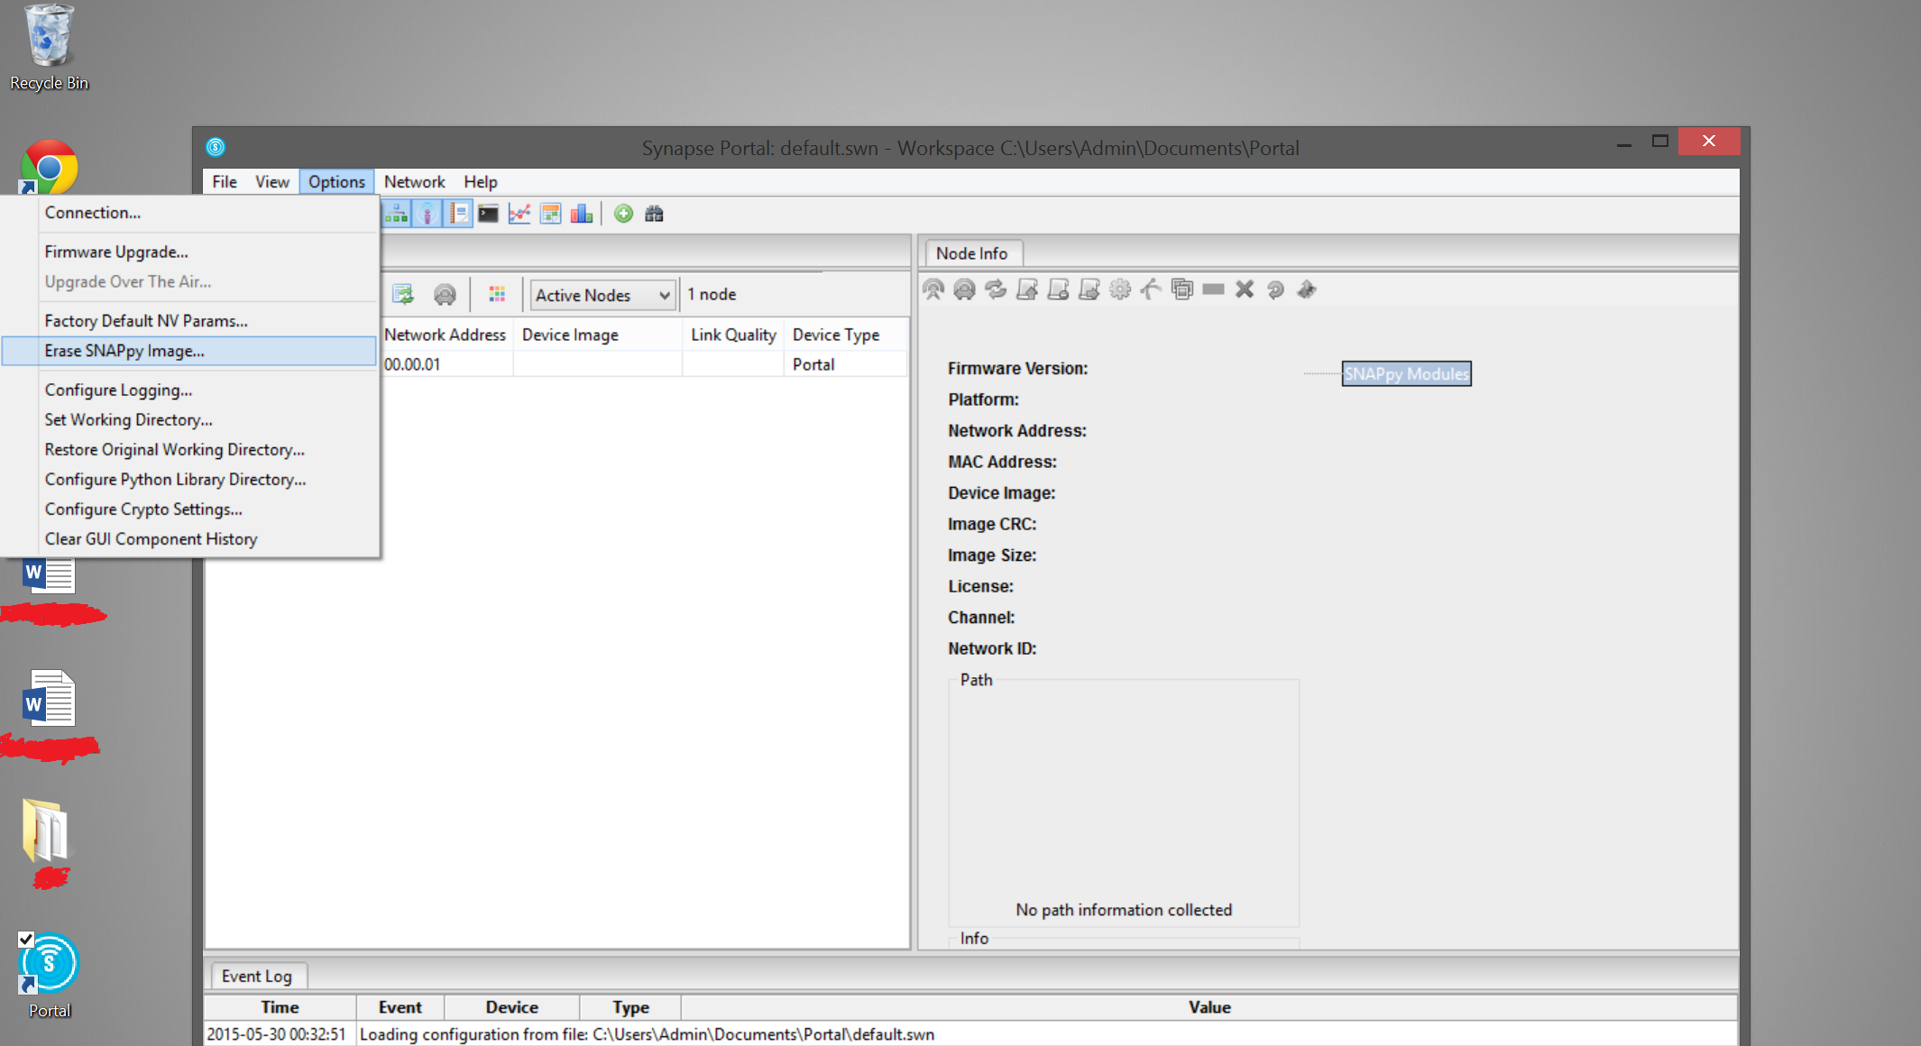

**Figure 25. Erase SNAPpy Menu under Options**

1. That will make the following window appear:

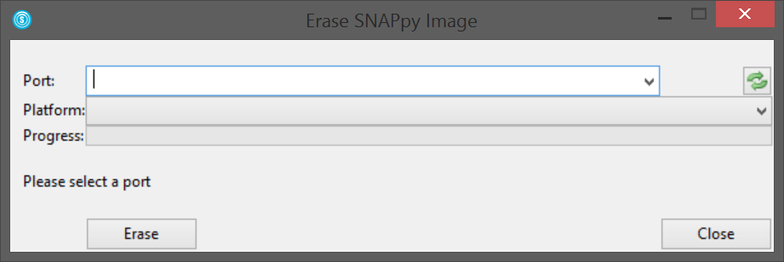

**Figure 26. Erase Window**

1. Hit the  button on the right side which should fill in the port dropdown with the correct COM port.
   1. If it does not automatically fill up, hit the drop down arrow and there should only be one listed COM port, choose that COM port.
2. Once the COM port is selected, click on the Platform dropdown. Choose “RF300” from this dropdown menu.
3. Once the Port and the Platform are chosen, hit the “Erase” button.
4. At point, it will ask you to restart the device by shorting pins 23 and 24. Refer to the “Restarting RF300 Chips while on Protoboard” section to see how to accomplish this.
5. Once the pins are shorted the firmware upgrade will start.
   1. If any errors come up during the flash, hit “OK” on the error and hit “Erase” again. You may need to repeat this process a few times.
6. Once the Erase process finishes without errors, the firmware is now in a usable and prepped state again ready for flashing. Refer to the original flashing sections for PC Readers, Reader Nodes, or Location Tags for instructions to flash the RF300 chips.

# 

# Hardware Assembly

## This section goes over the physical assembly of the different RF300 chips once they have been flashed and their different power sources.

## Soldering Reader Node Power Cable:

The reader nodes need an external power source to run, in this case small 3V power supplies. In order to connect them to the power supplies you must create power adapters. A completed power adapter is shown below.

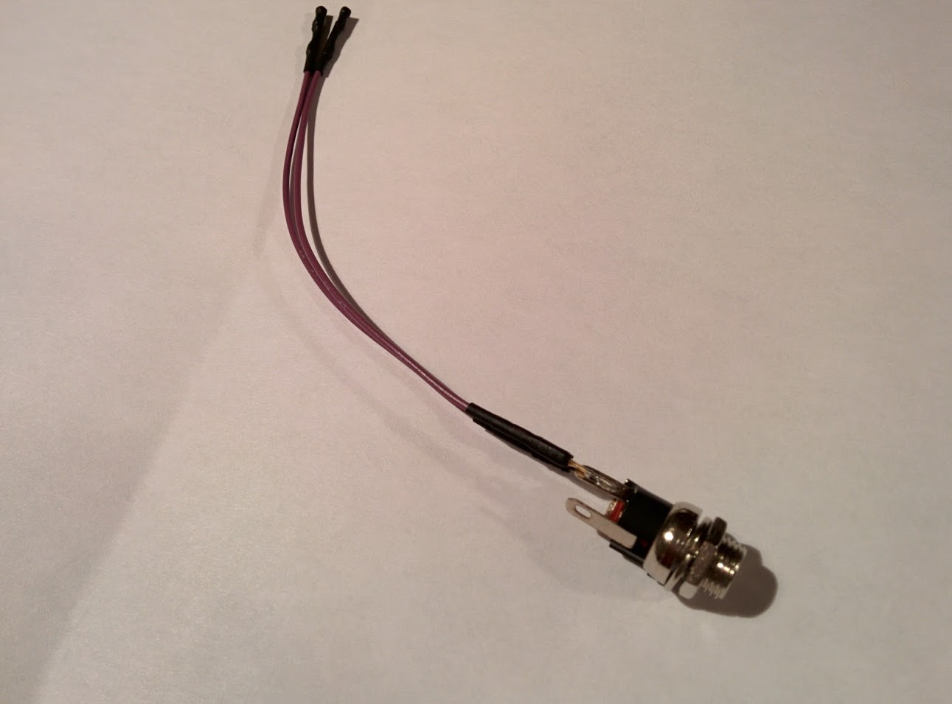

**Figure 27. Completed Power Adapter**

To create these you must solder jumper cables (see figure 6) to female power adapters. The female power adapters have three terminals on the ends. There will be two terminals which are across from one another (the two positive terminals) and one lone terminal with nothing across from it (the negative terminal) as shown in the diagram below.

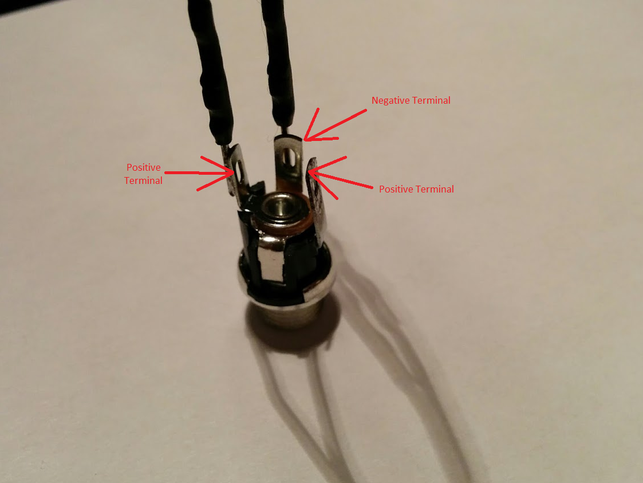

**Figure 28. Labeled Terminals**

In order to make the correct connections (one negative and one positive) you need to solder a male end of a jumper cable to one positive and one negative terminal. Here is an example of a soldered terminal.

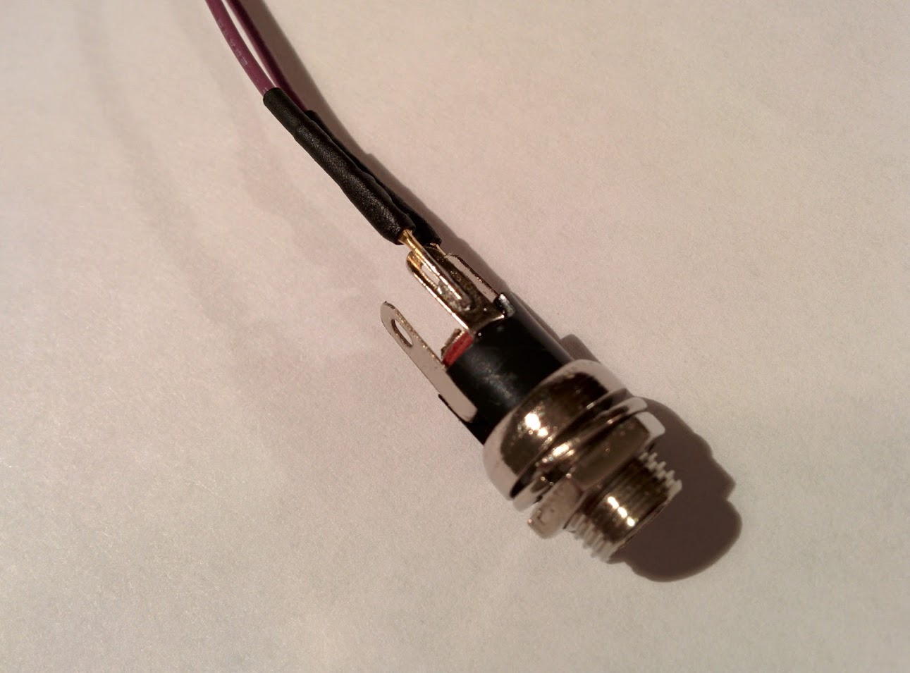

**Figure 29. Soldered DC Adapter**

Now to connect it to an RF300 chip which has been flashed as a reader node, you must connect the female end of a jumper cable (which has been soldered to the negative terminal on the DC adapter) to pin 24 on an RF300 chip and the female end of a jumper cable (which has been soldered to the positive terminal on the DC adapter) to pin 21 on an RF300 chip (refer to the RF300 Pin Layout section for help on identifying the pins). The end result will look as displayed in the picture below.

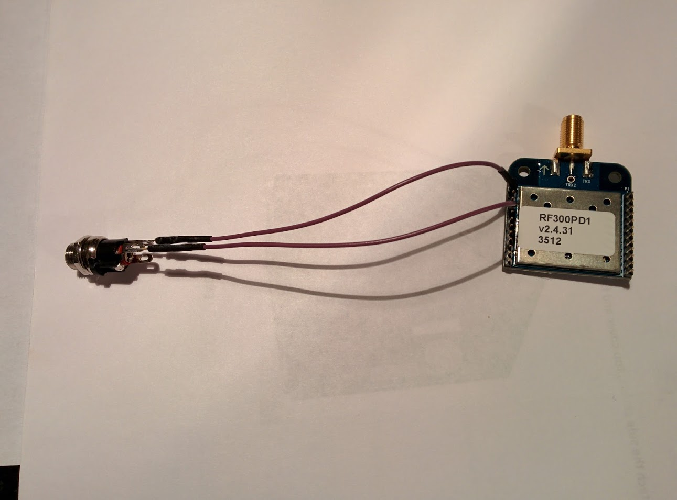

**Figure 30. RF300 connected to DC Adapter**

Here is a closer shot of the connections.

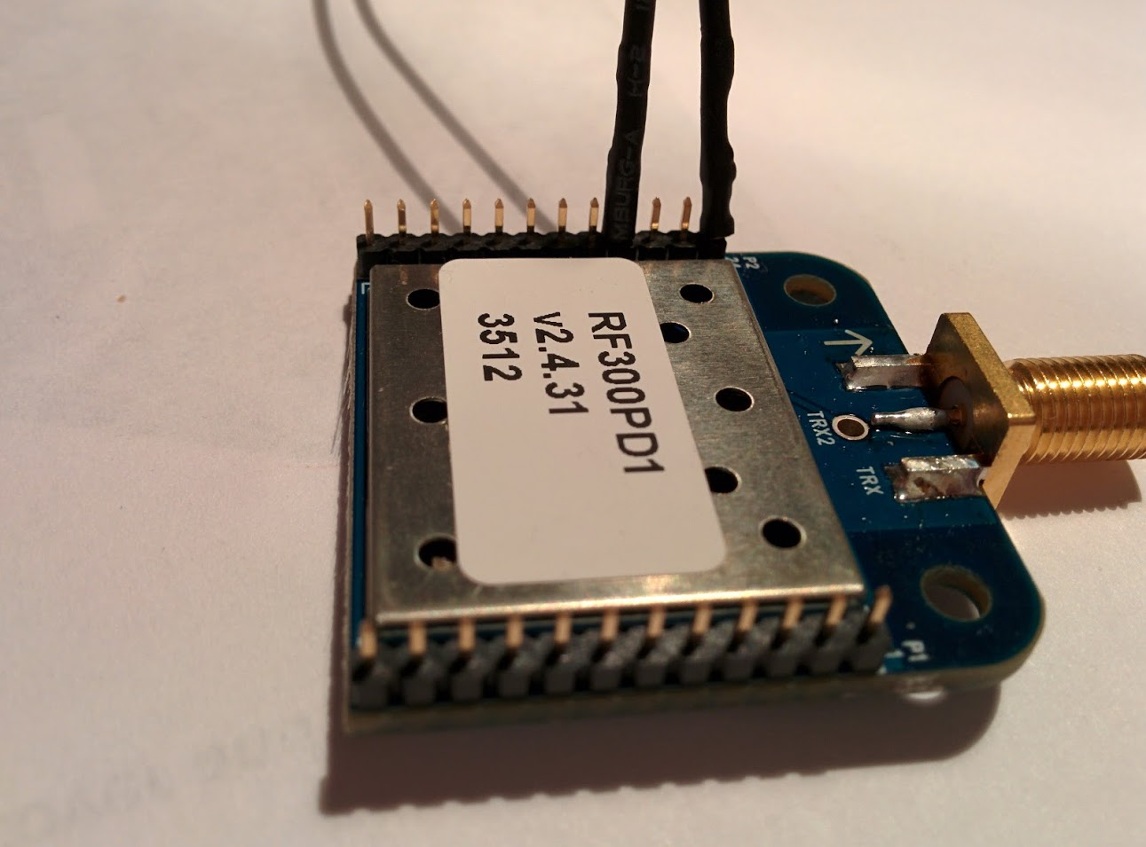

**Figure 31. Female Jumper Ends on Male RF300 Pins**

As you can see the female ends of the jumpers slide onto the pins and cover them.

**NOTE:** **You may need to pinch the female ends of the jumpers a bit in order to make strong contact with the pins on the RF300 chip or else the connection may be loose.**

Now once you connect the female power adapter to the male end of a power supply as shown below, your reader node will be ready for power.

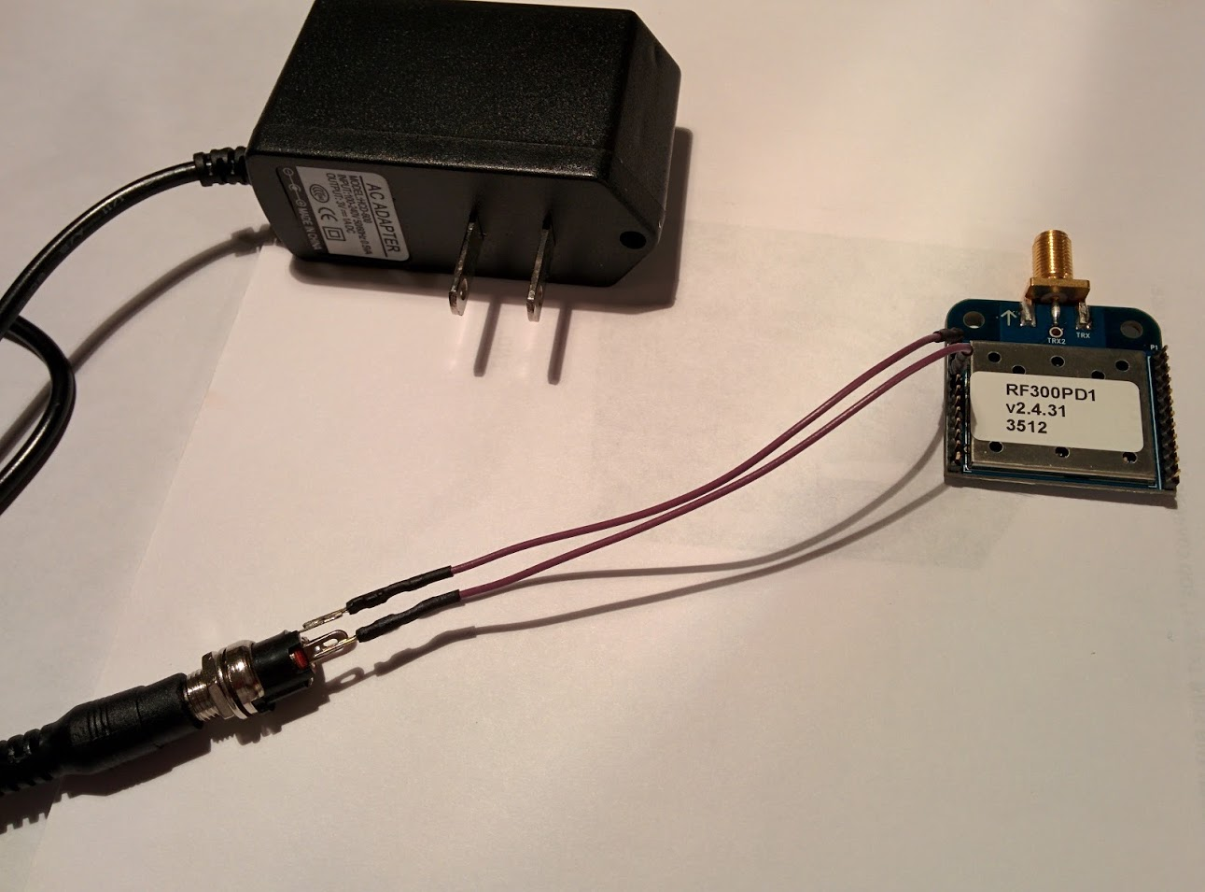

**Figure 32. Powered Reader Node**

## Soldering Location Tag Power Cell:

Each location tag will need its own portable power source. These power sources will be CR2032 batteries housed in battery cell holders which will connect to the tag. Here is an image of a finished battery cell holder.

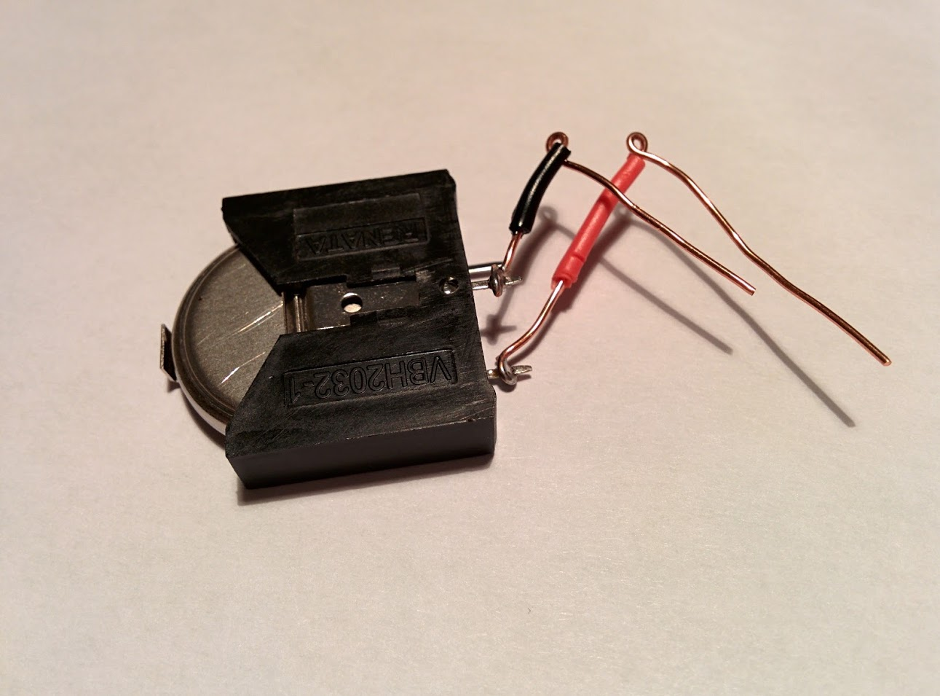

**Figure 33. Positive/Negative Connection 1**

As you can see in the image, the battery cell holder has 3 terminals, two are positive and one is negative. The two positive ones are labelled on the battery cell holder with a “+” symbol as shown in the image below.

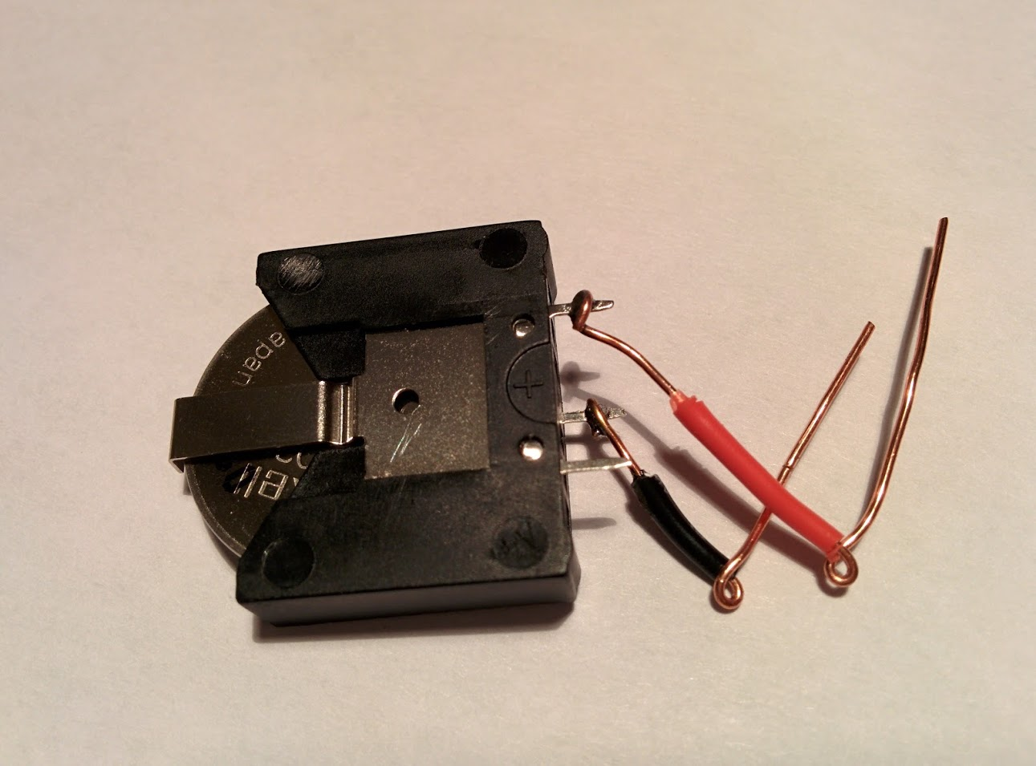

**Figure 34. Positive/Negative Connection 2**

The other side will have one lone terminal which will be negative. For this you will want to solder one wire to a positive terminal and another wire to a negative terminal. In the examples we have used a black wire for negative and a red wire for positive. Refer to figure 7 for an alternate view of positive (below) and negative (above),

**NOTE: Do not solder any wires with the battery in the cell holder, remove all batteries before any heat is applied while soldering.**

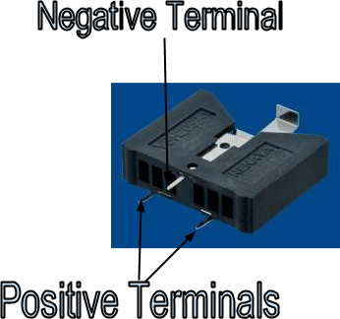

**Figure 35. Positive and Negative Locations**

Just as in the reader node power adapter, you must connect the black wire (which has been soldered to the negative terminal on the battery cell holder) to pin 24 on an RF300 chip and the red wire (which has been soldered to the positive terminal on the battery cell holder) to pin 21 on an RF300 chip (refer to the RF300 Pin Layout section for help on identifying the pins). In the images seen above, we created loops on the end of each wire to ensure good contact without the need to solder the wires directly onto the RF300 chip. Below is an image of a tag connected to a finished battery cell holder.

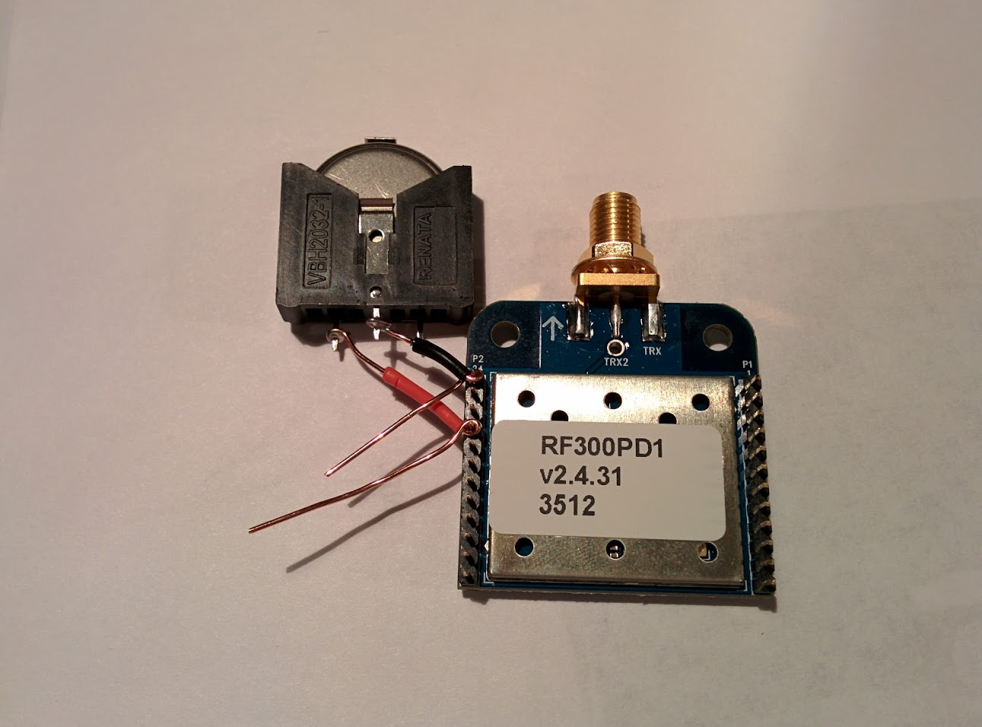

**Figure 36**.**Battery Connected to RF300 Pins**

Another angle showing the connection:

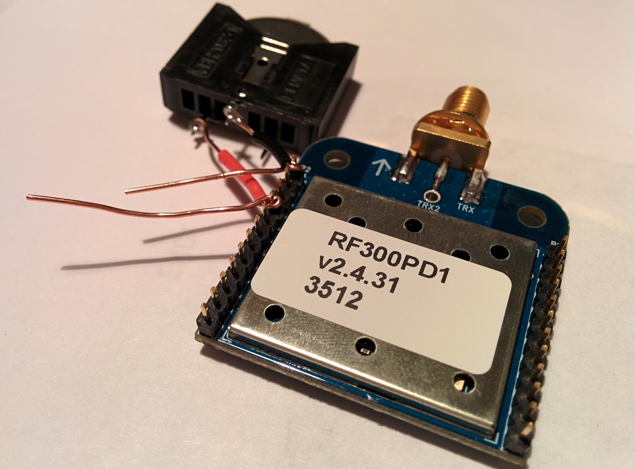

**Figure 37. Zoomed View 1 of Battery Connected to RF300 Pins**

And a third shot showing a close-up of the connections:

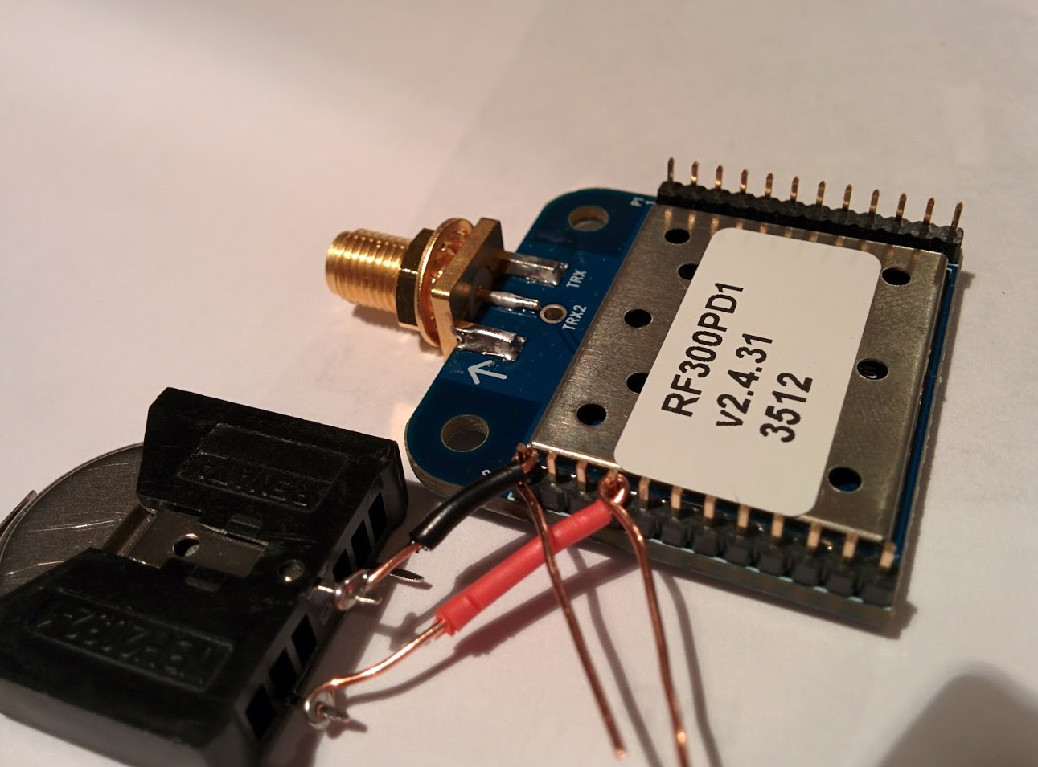

**Figure 38. Zoomed View 2 of Battery Connected to RF300 Pins**

With that, the battery cell holder is ready to power an RF300 chip flashed as a location tag.

**Attaching a PC Reader to the Computer and Power:**

The PC Reader is powered by the Protoboard and its power supply. This means that no soldering is necessary. The following instructions describe how to connect the RF300 chip which has been flashed as a PC Reader to the computer and how to power it.

1. Connect the RF300 chip which has been flashed as a PC Reader to the Protoboard. For instructions refer to “Inserting RF300 into Protoboard” section.
2. Connect the Protoboard to its power cable and connect the power cable to an outlet.
3. Using the USB adapter, hook up the Protoboard to the computer running the Location HTTP Forwarder software.
4. The image below shows the completed assembly.

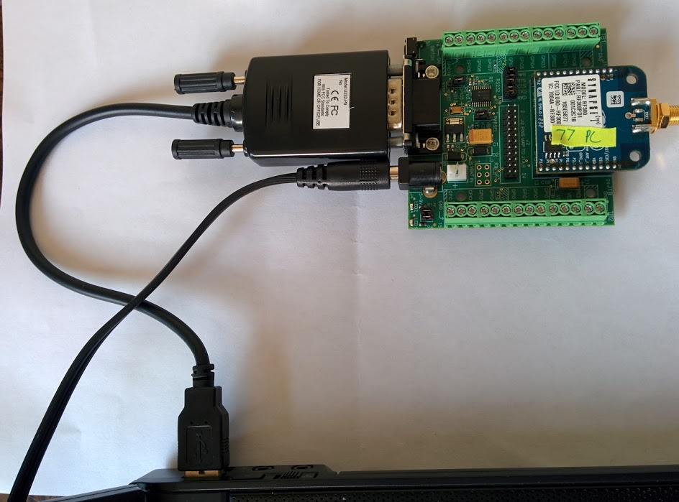

**Figure 39. Attached PC Reader**

## Attaching an Antenna to the RF300 Chip:

Each RF300 chip will need an antenna to amplify the signal range regardless if it is a reader node, location tag, or PC Reader. The jumper cables pictured in figure 6 will function as antennas. To attach these jumper cables to the RF300 tags as antennas, simply push the female end of the jumper cables onto the male end of the RF300 chips antenna port as seen below.

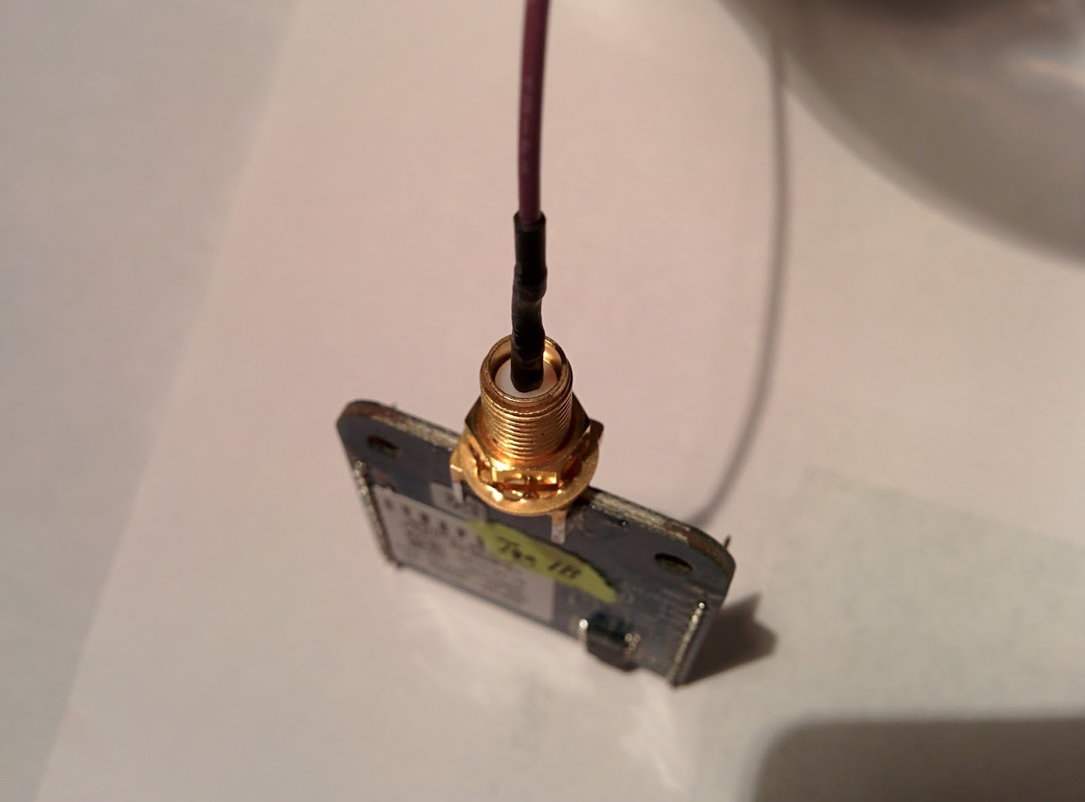

**Figure 40. Female Antenna End to Male RF300 End**

The finished product is seen below.

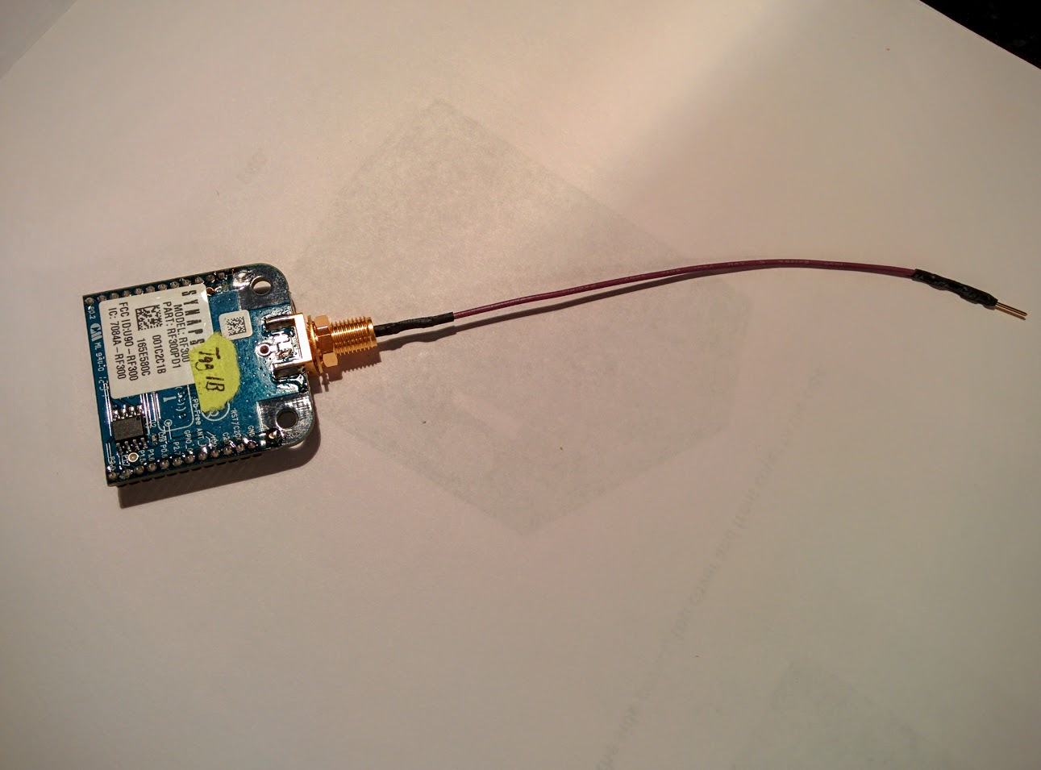

**Figure 41. Antenna Attached to RF300 Chip**